**Understanding Node JS**

* Javascript –V8 Engine ( This engine will convert JavaScript code to machine language)
* V8 Engine/Node Engine is written in C++
* V8 Engine follows ECMA standard (**Ecma** is a [standards organization](https://en.wikipedia.org/wiki/Standards_organization) for information and communication systems)

Node JS is not Javascript. It is C++ code which accepts javascript

Node JS takes cares of the following points as Web Server

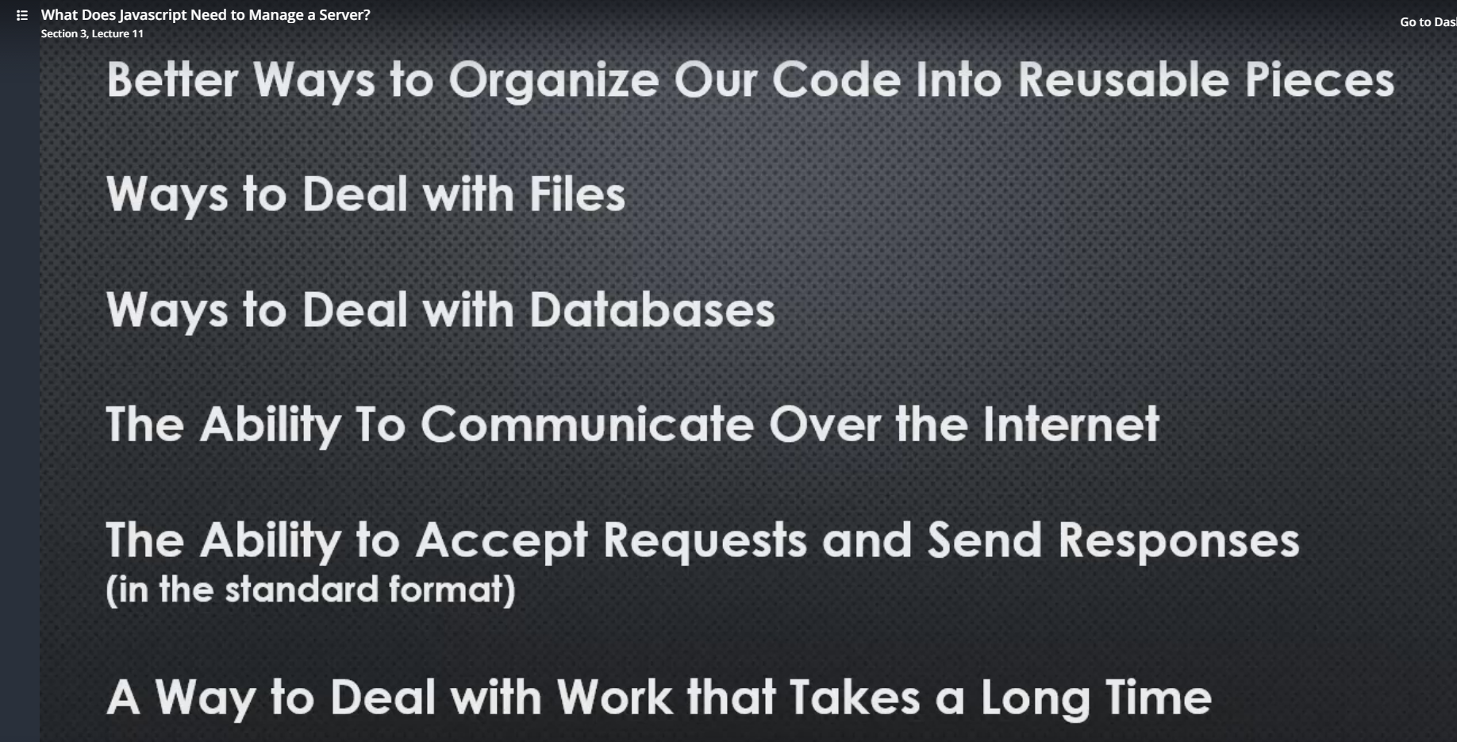

Modules/Export/require

**Module/Require**

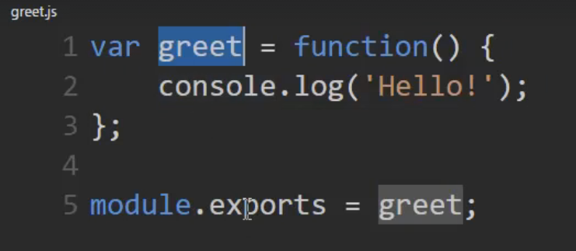

* Here greet function is made available outside the current module
* Importing greet using require keyword

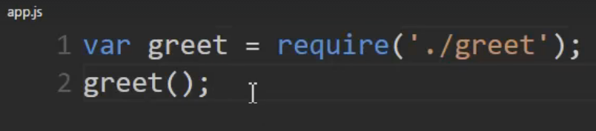

**Internally Node wraps up our code and uses this function and returns module.exports**

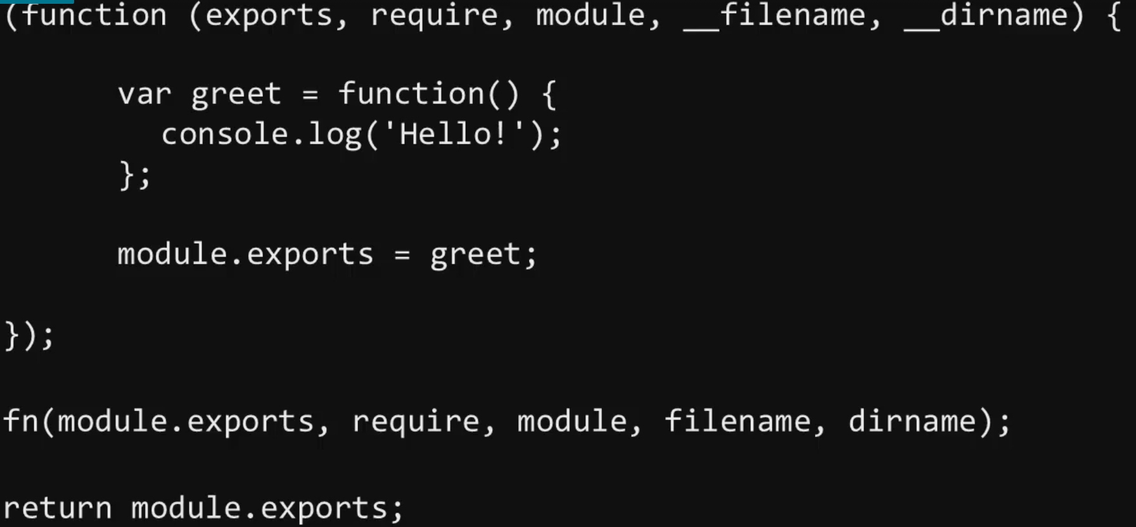

**Require can also be used to include a directory – using this corresponding pattern**

* When a folder is used in require – it will look for index.js

The below example has two javascript files – english.js & spanish.js

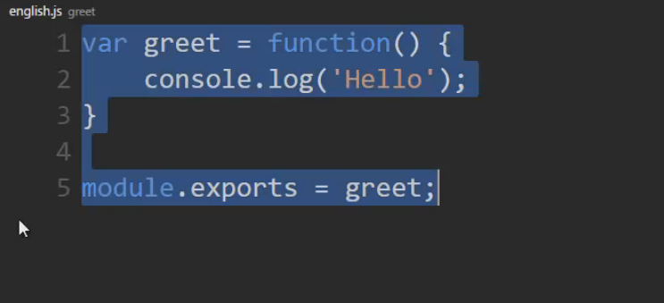

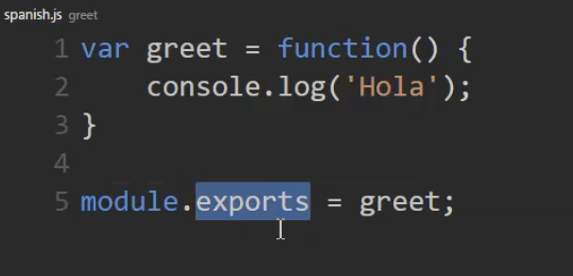

Now I have index.js which requires English.js and Spanish.js and each one gets associated with the property greet() and named as English and Spanish respectively

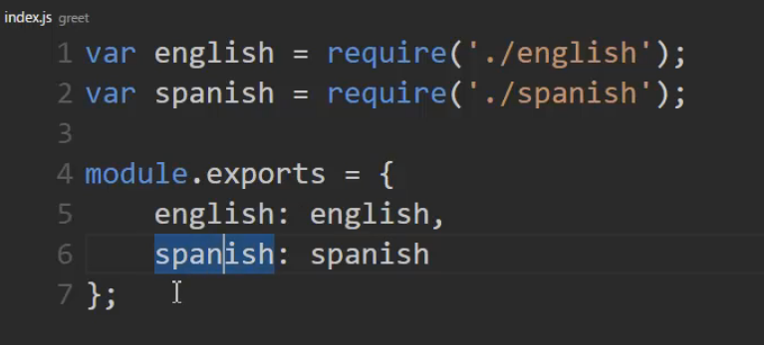

Here in app.js require imports greet folder and looks for index.js and get the required properties

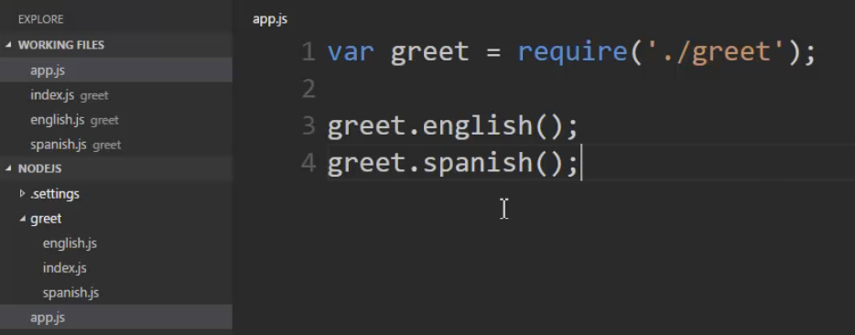

**Reading JSON file, automatically we can access properties of JSON like below**

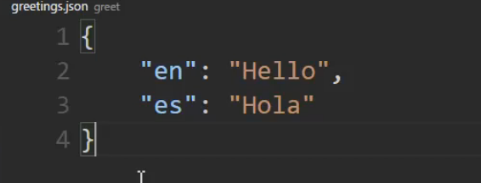

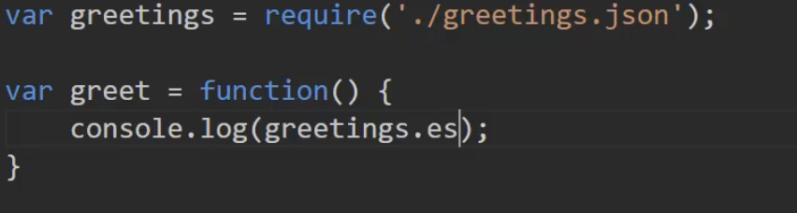

**More Module Patterns**

**Pattern 1: Returning function object**

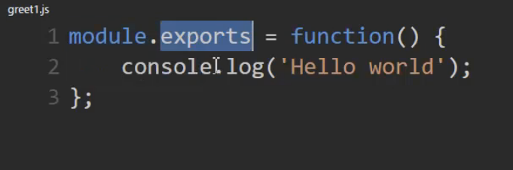

In app.js, the function is invoked as it is

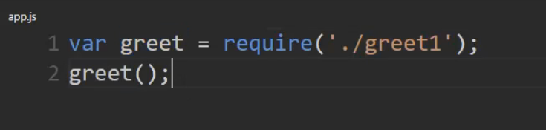

**Pattern 2: Returning property function object**

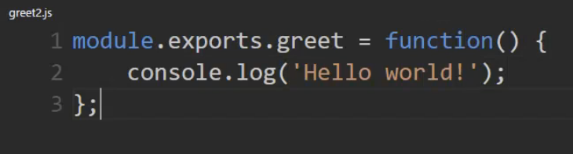

greet property is used and assigned to greet2

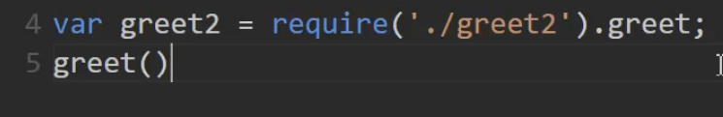

**Pattern 3: Using Function constructor – notice new keyword**

When new keyword is used, it returns this instance. Here this instance is returned to module.exports and it is passed on

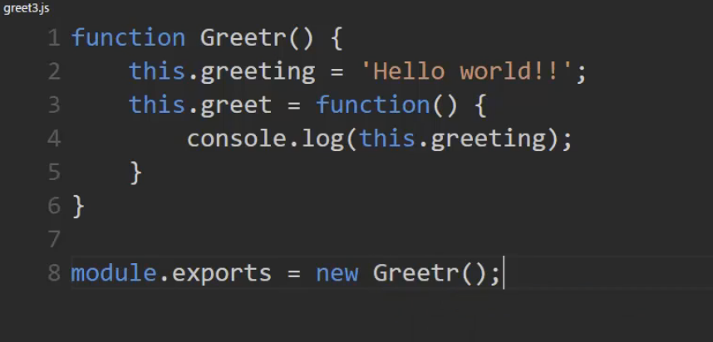

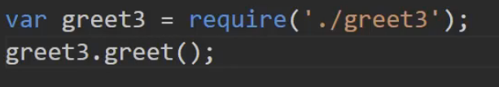

Notice – when require is invoked twice, the value of greeting gets changed ( Internally the value gets cached)

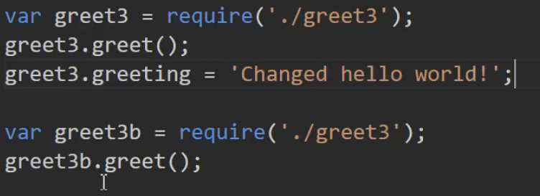

**Pattern 4: Function constructor is used in the calling function instead of modules.exports**

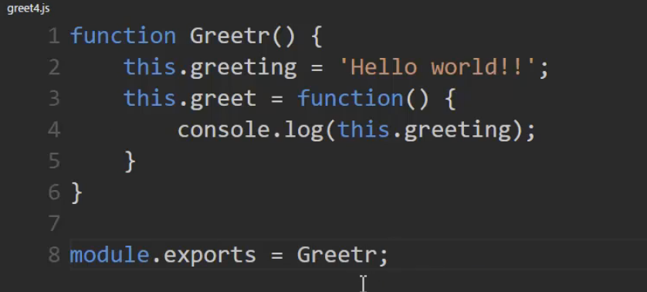

Notice – Here new Greet4() would get a new reference

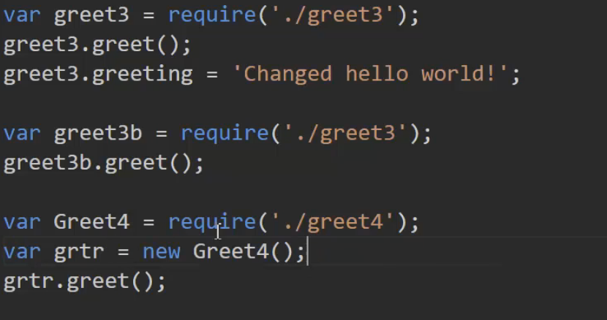

**Pattern 5: Important – Encapsulation**

* Here only the greet function is exposed but the variable greeting is hidden

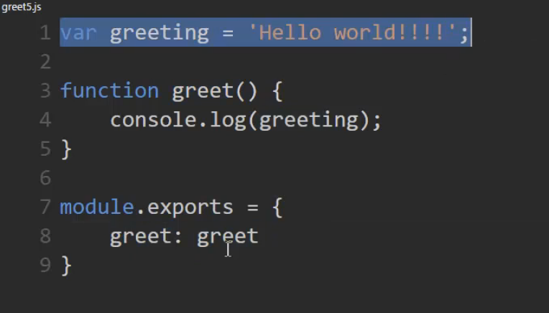

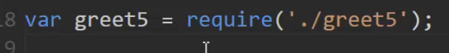

**New way of export and import**

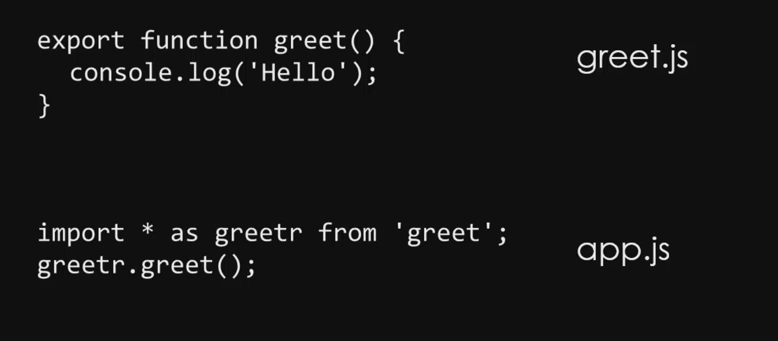

[**https://nodejs.org/dist/latest-v8.x/docs/api/fs.html**](https://nodejs.org/dist/latest-v8.x/docs/api/fs.html)

This link has got all the standard libraries

**Example using util module**

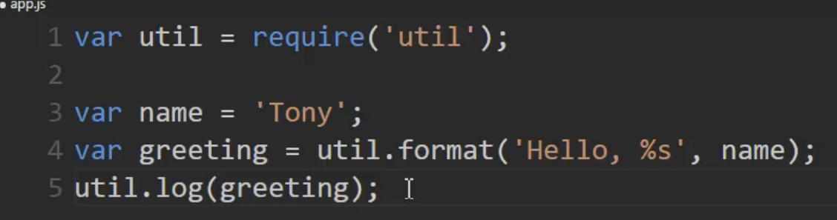

**Node JS & Events**

* System Events – Like file system full etc 🡪 Handled on the C++ side
* Some system events are triggered as Javascript events so that we can use it in our application
* Also, we can create custom javascript events

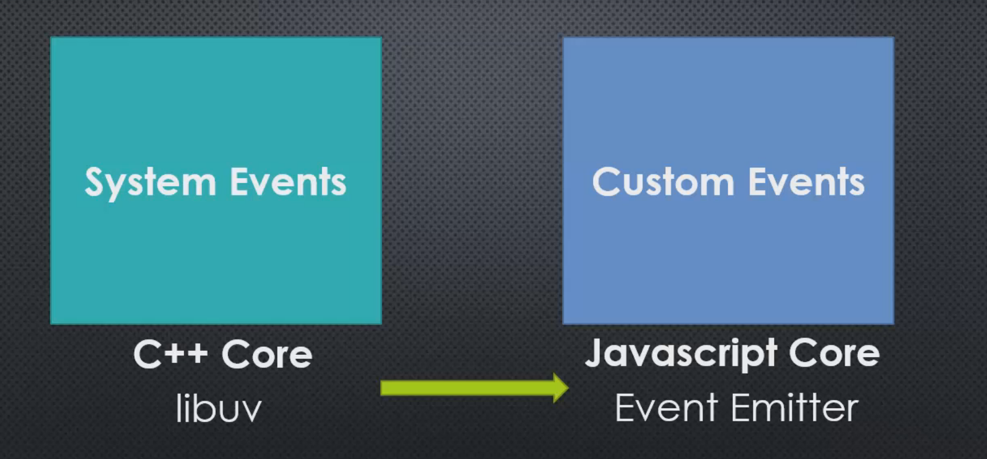

**Emitting Events**

* Creating a function constructor named Emitter
* .on takes a function
  + Function has two params – register types of events and corresponding listener 🡪 from outside this listener is passed as a function object
* Emit function emits events – (ie) it is calling listener function based on the type of events

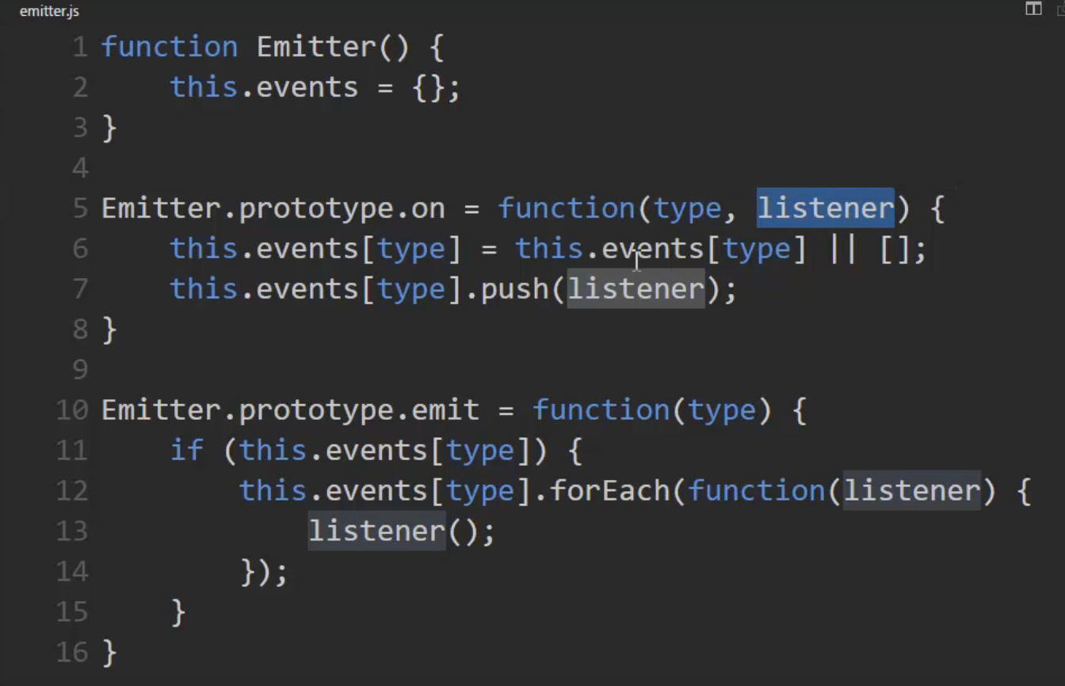

* Two types of events are registered below.
* When emit is invoked, type of event is looked up and the appropriate listener function is called

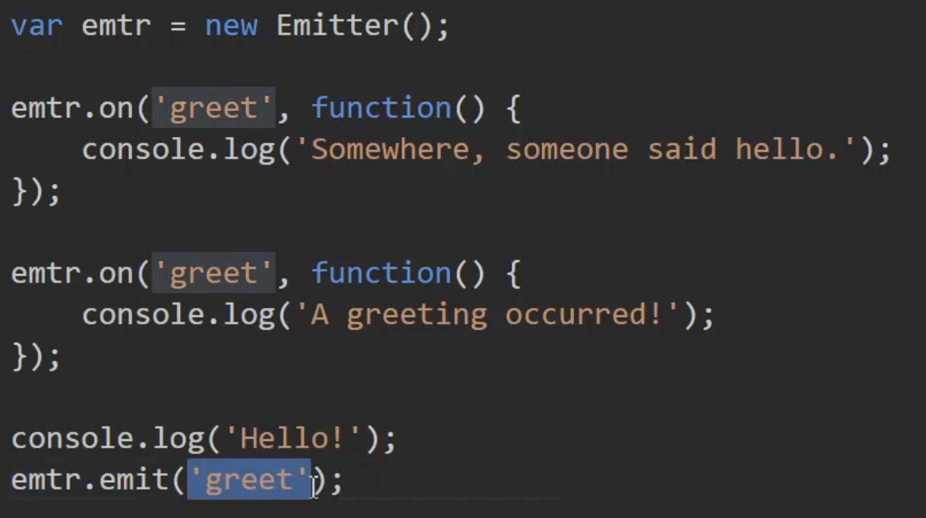

**Node Event Emitter – Rudimentary way**

* Using the existing built in node package events
* Events provides functions like on and emit – we call it appropriately

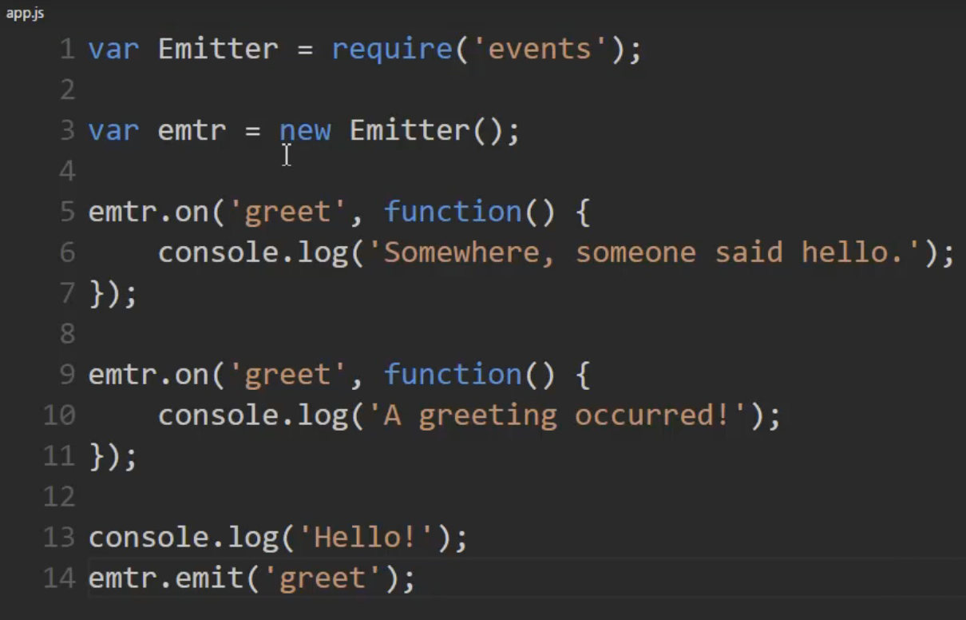

* Here magic string is ‘greet’ – if we make a typo in calling it is very difficult to identify

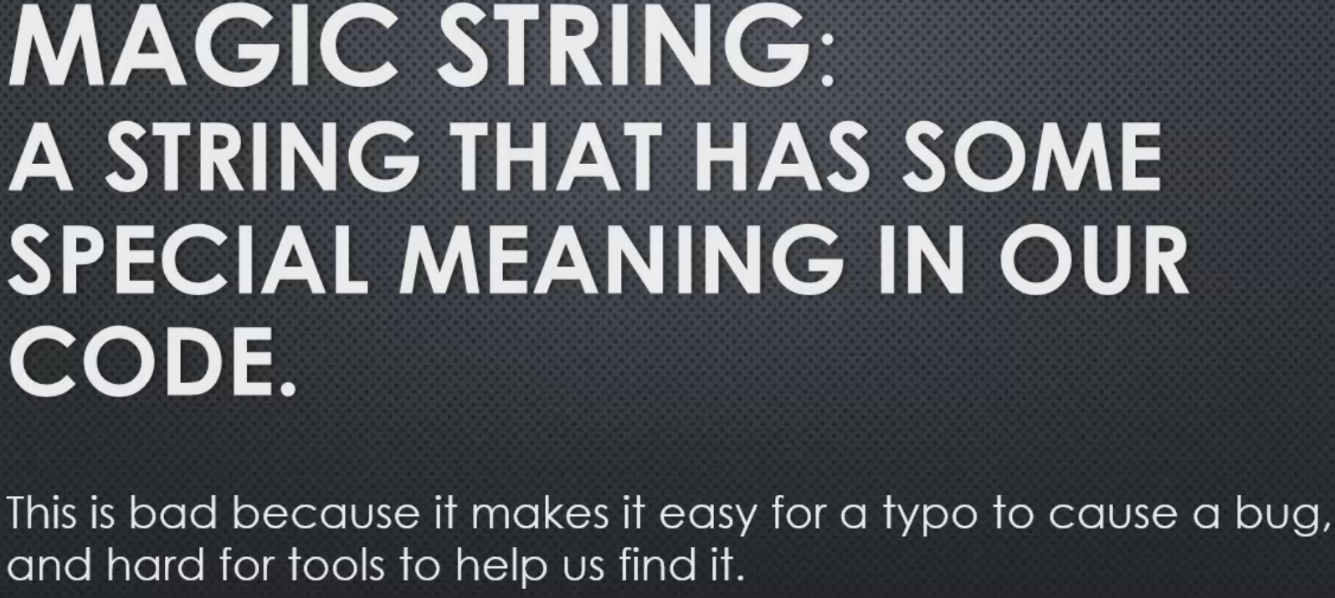

**Node Event Emitter - Good pattern**

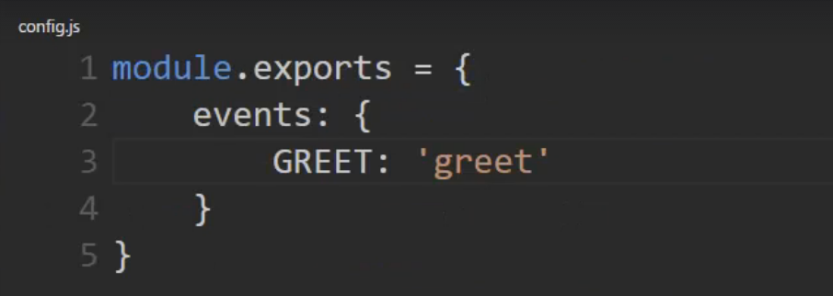

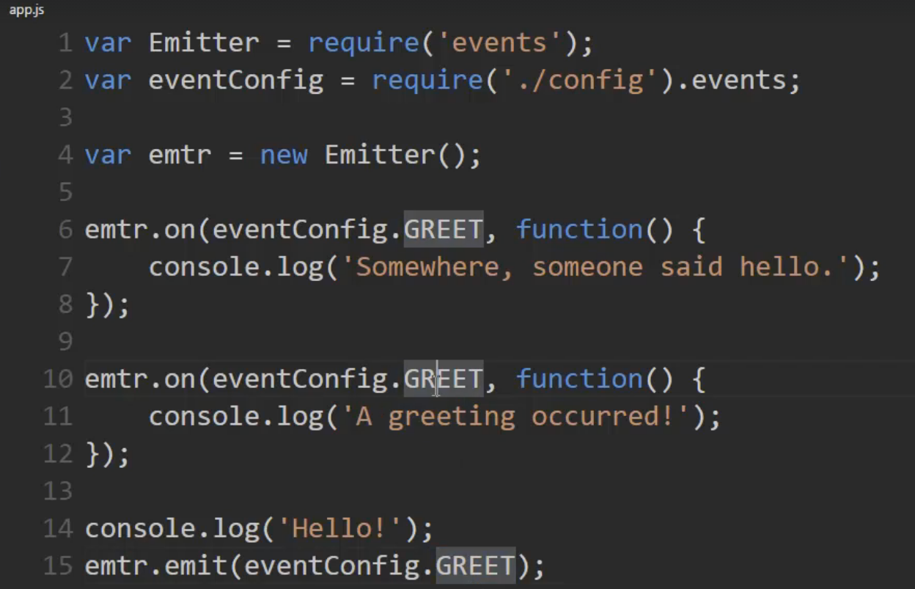

**Prototype Chain Revisited**

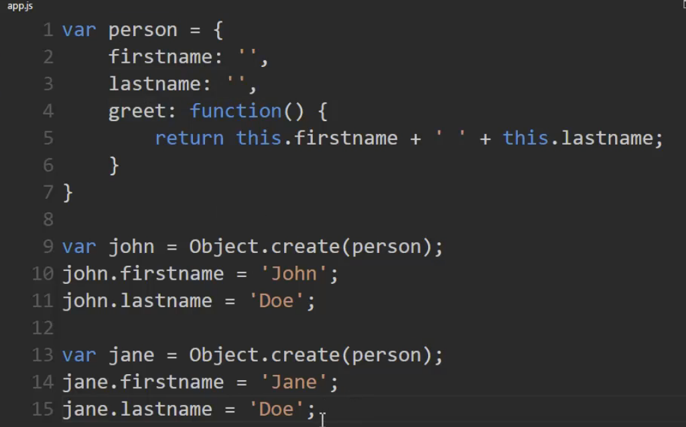

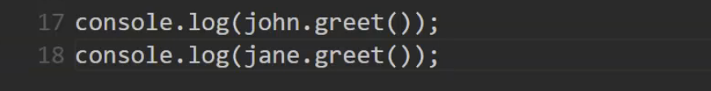

* Instead of Object.create, we can use function constructors as well
* First john object of type person is create and is assigned with firstname and lastname
* Next jane object of type person is create and is assigned with firstname and lastname
* When using Object.create 🡪 properties of person is inherited in john and jane using prototype inheritance. John and Jane have just the firstname and lastname but don’t have the greet method. This will be inherited from the chain below

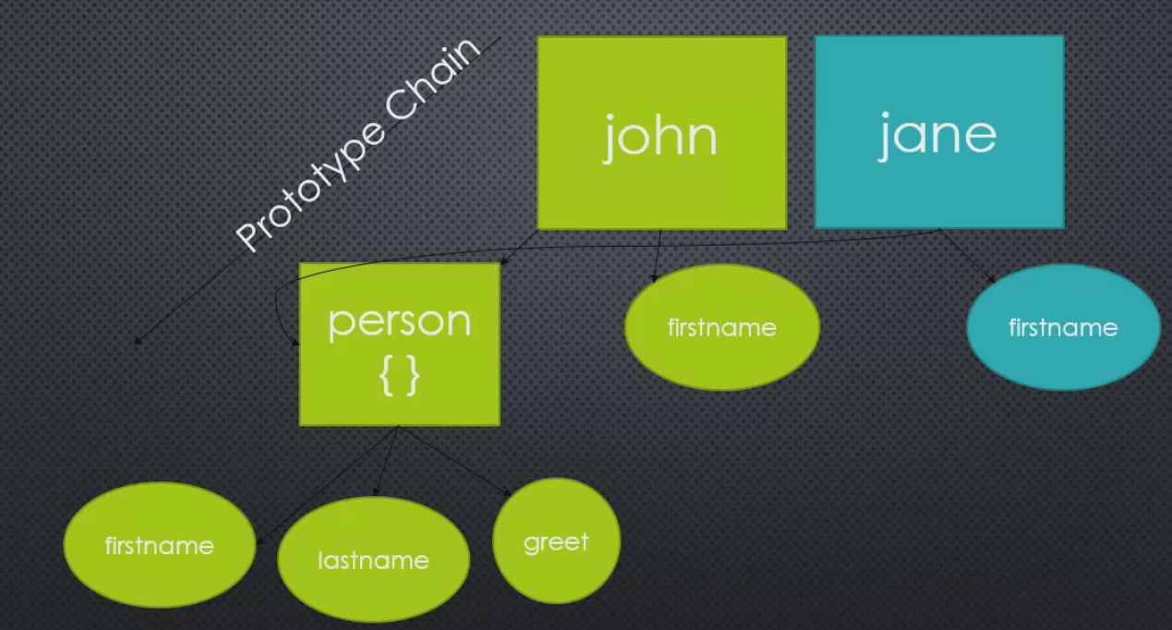

**Function constructors Revisited**

When a function is invoked using a new keyword, it becomes function contructor

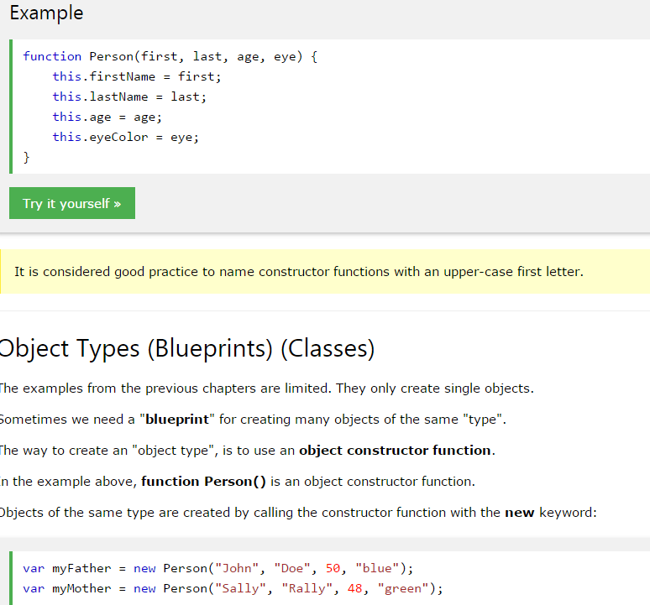

**Template Strings**

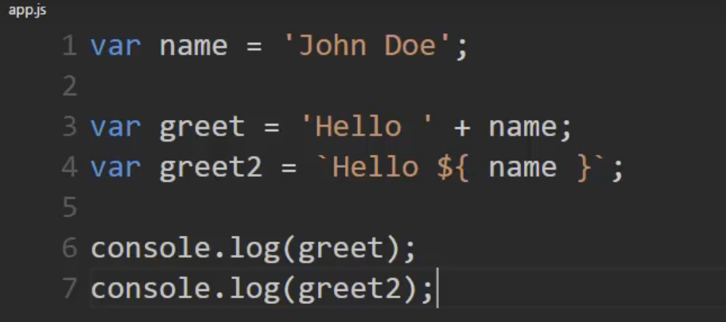

Notice the $ sign and {} . This is the new feature in V8 Engine which cannot be directly used in browser. However, using babel.io library it can be supported

**ES6 Classes**

Classes is just syntatic sugar but underlying stuff doesn’t change much and it is the same.

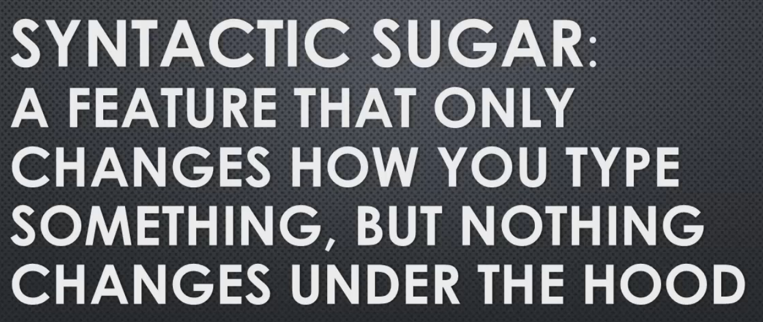

**Without classes**

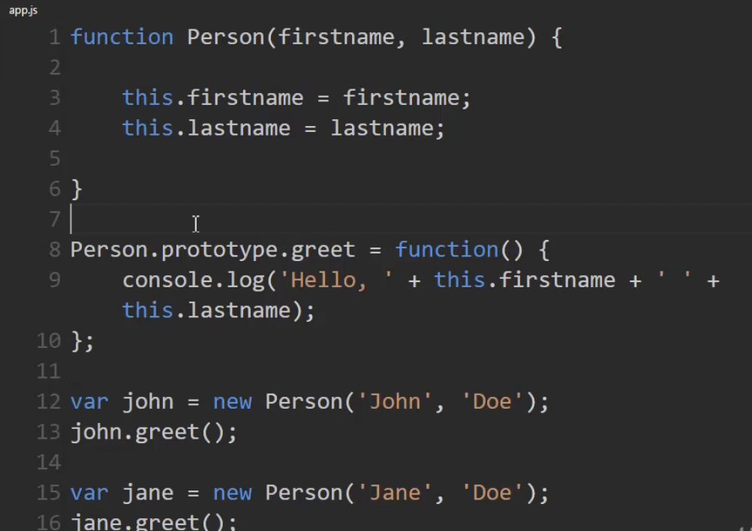

**With Classes**

* use strcit is mandatory inorder to use classes
* Instead of Function contructors, here is it is explicitly called as constructor
* Once you define a function inside a class – it gets attached to the particular prototype

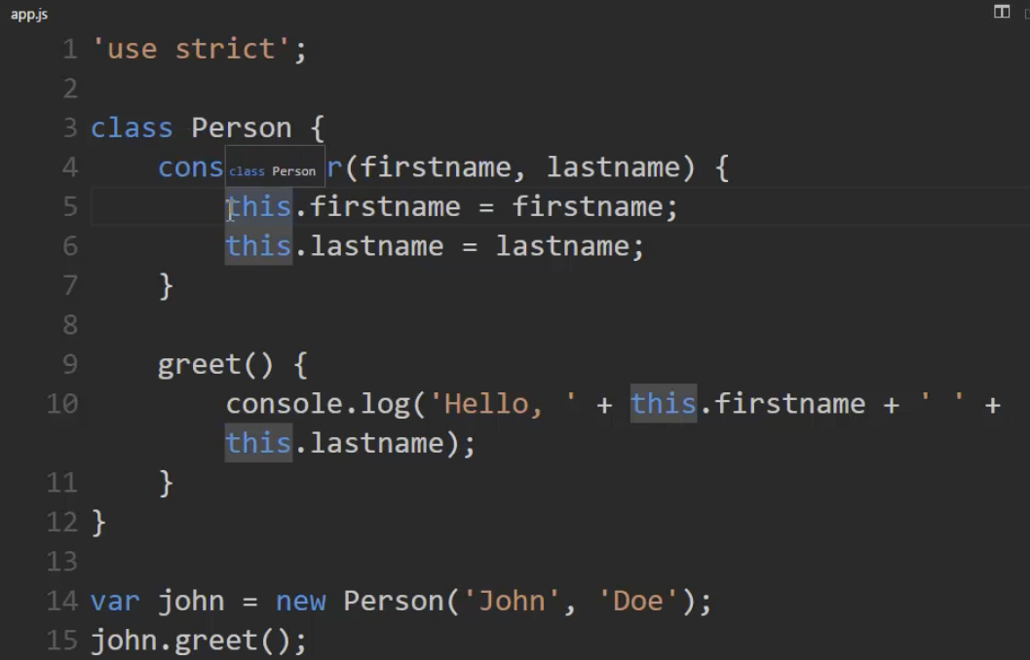

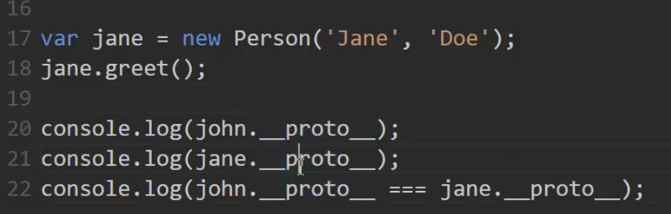

When Inheritaning, the below syntax can also be used instead of setting to prototype

* Here Greetr extends properties of EventEmitter
* Super keyword gets this properties of EventEmitter

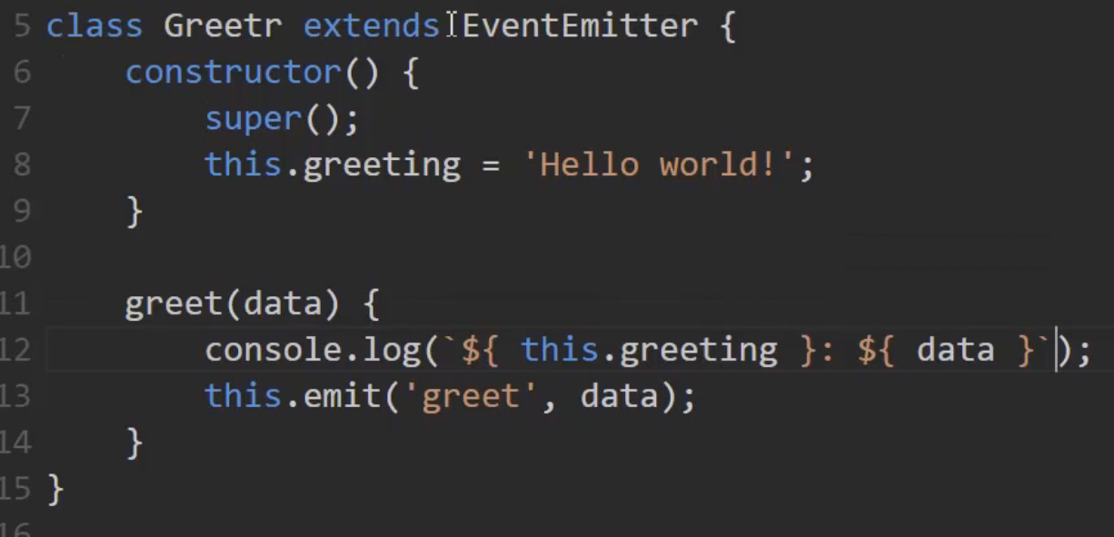

**LIBUV**

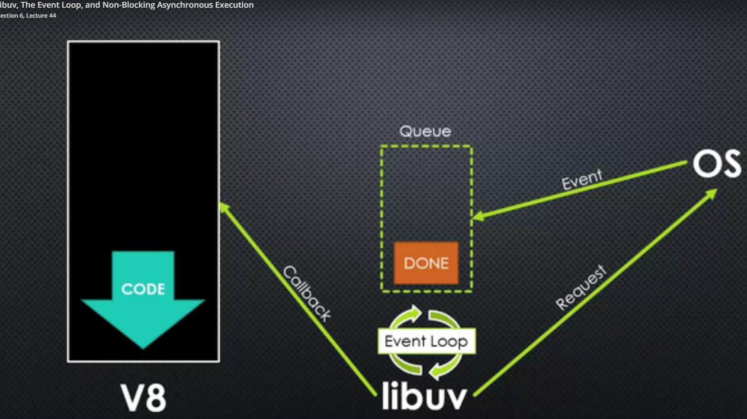

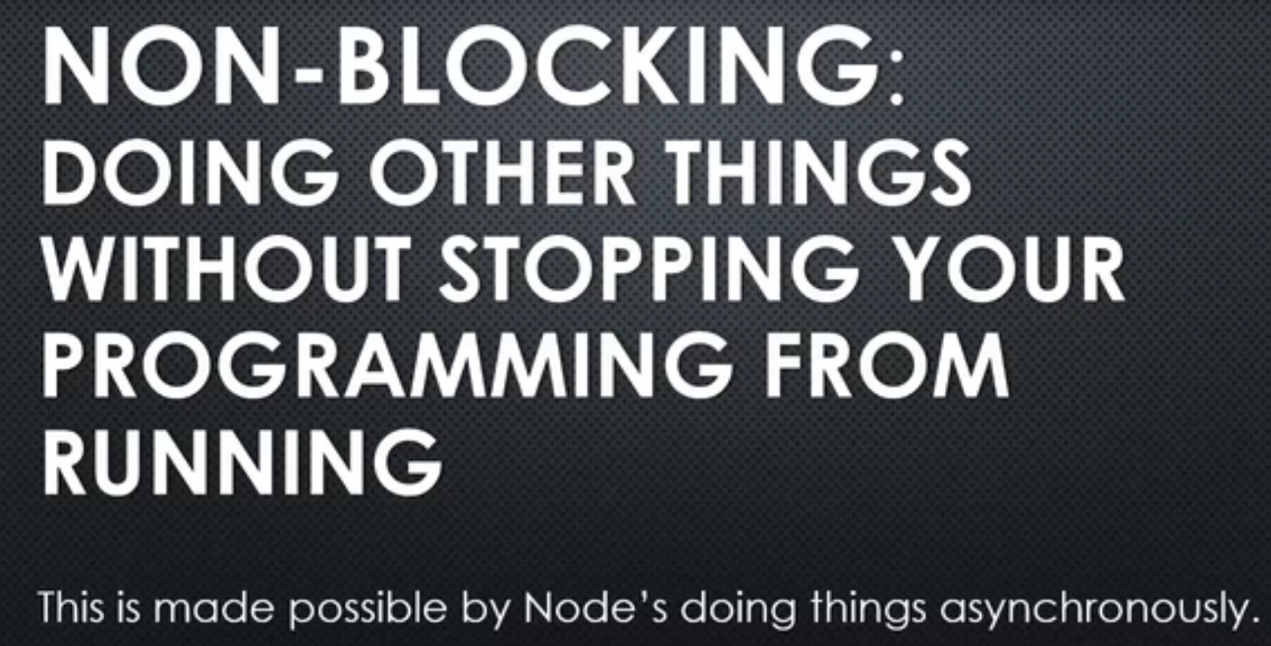

As and when events complete, respective callback will be invoked. These callbacks will be run in background by Node

**Streams and Buffers**

* Buffers – Temporary storage of data
* Streams – Large chunk of data for specific time/duration is streamed/processed

**Buffer Creation**

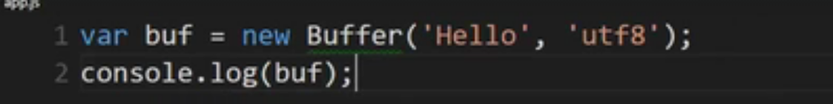

**Files**

var fs = require(‘fs’)

fs – file system

**Reading the file in synchronous way**

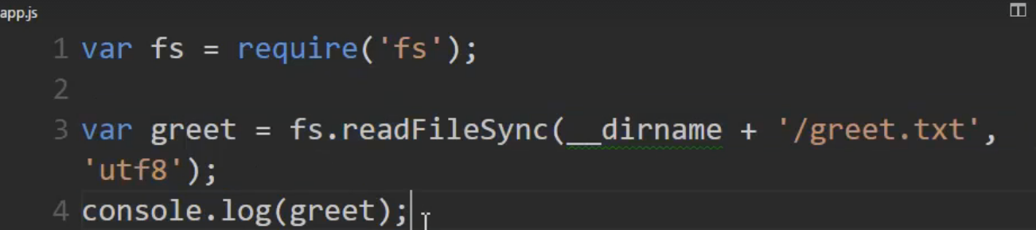

**Reading the file in asynchronous way using Callback**

* First parameter is the error in NodeJS

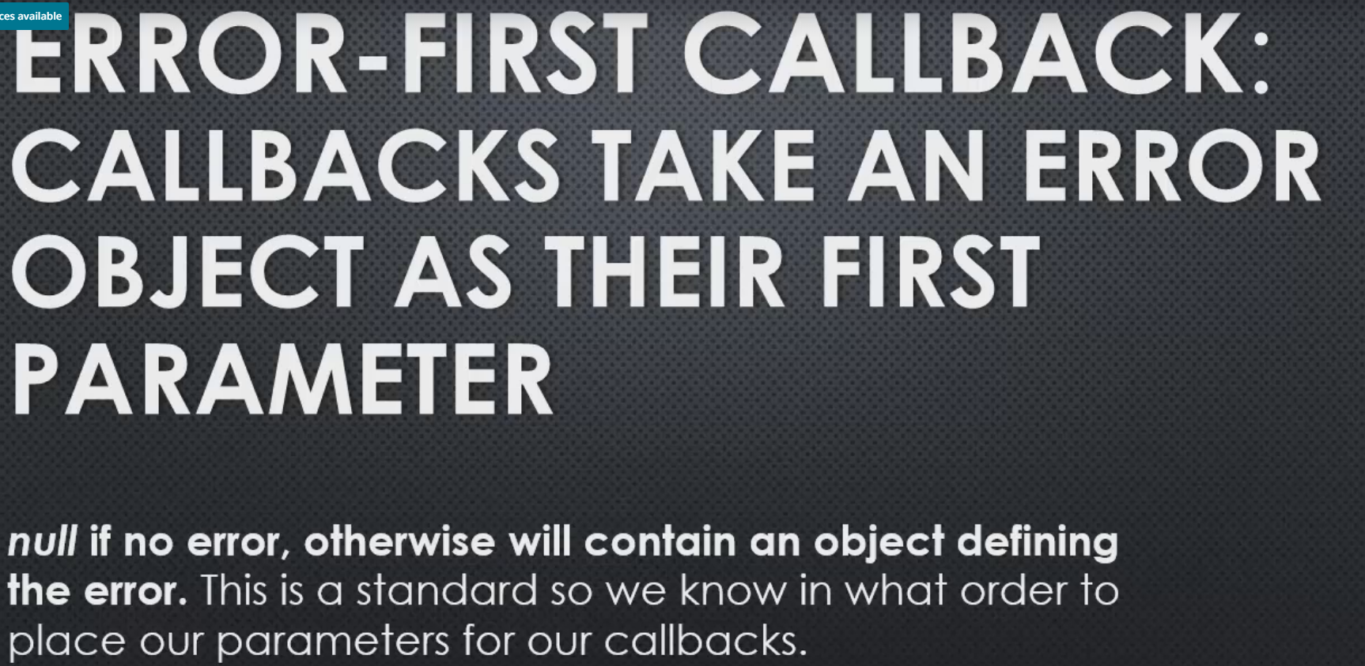

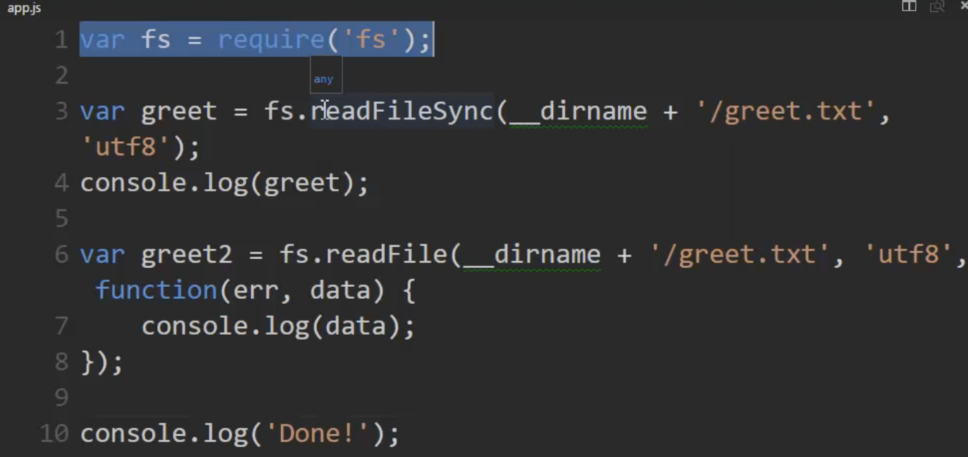

Done got printed and then the Hello World got printed. This is asynchronous callback

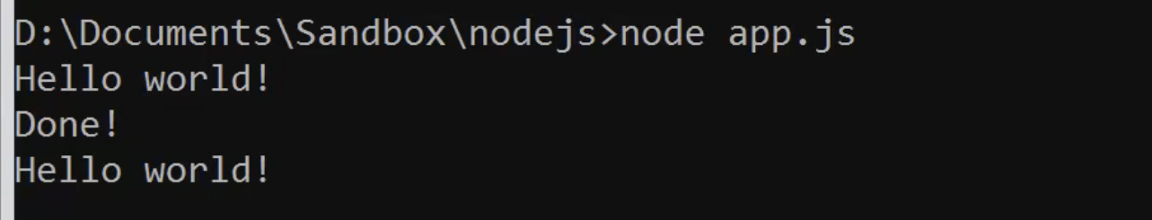

If the file size is huge then using Buffer might occupy a lot of memory.

**Streams**

**Types of Streams**

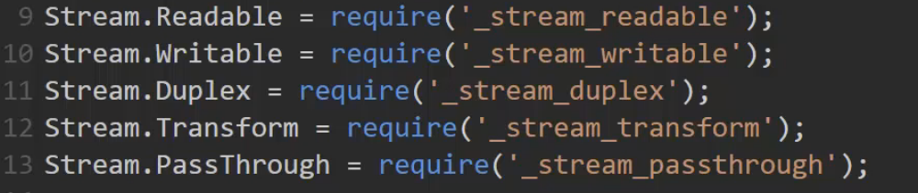

* Here request is a readable stream and response is writable stream

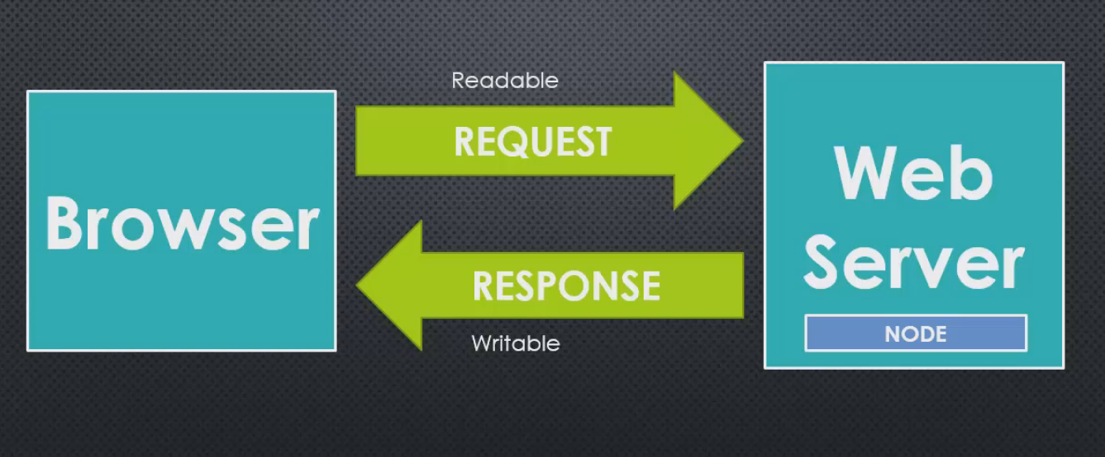

* Instead of reading the entire chunk in Memory, Streams reads partially

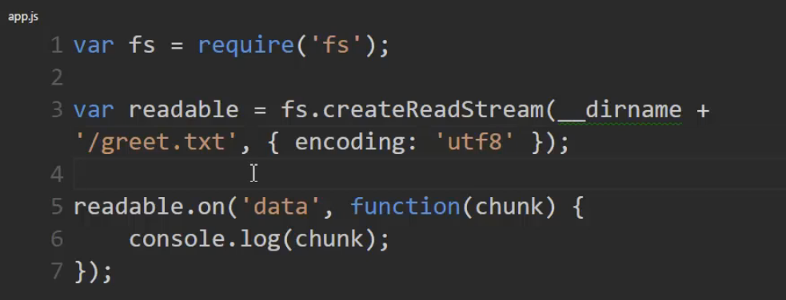

Readable & Wrtiable comibned

* Number of bytes to be part of Buffer

